PHOTO STORY FROM POKO GARAGE EVENT RESPONSE OPERATION 2017 (GPS COORDINATE: N06 27 31.8 E003 21 58.7 {INCIDENT POINT})
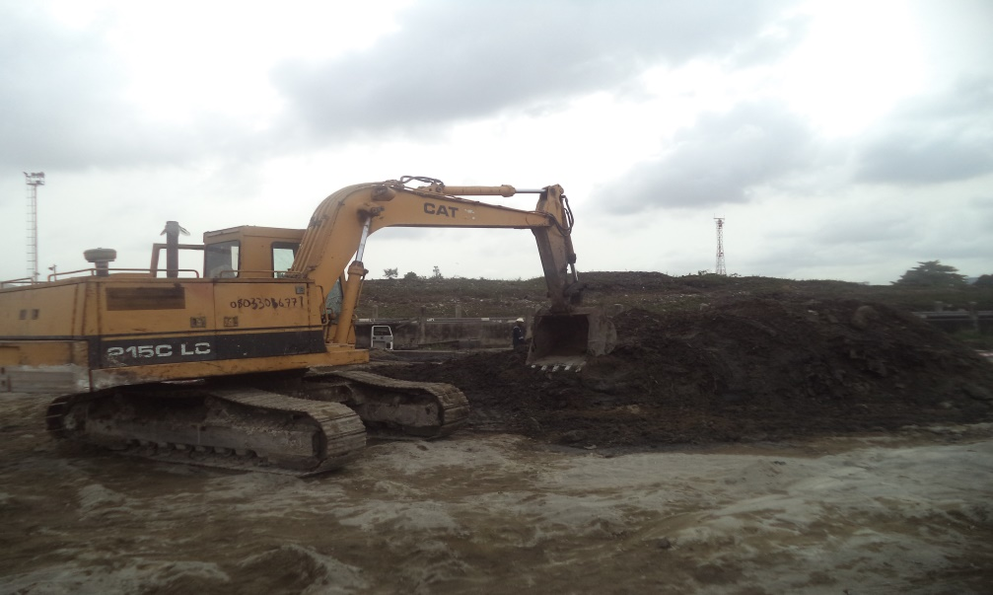
FIG 1: EVACUATION OF SAND FROM THE INCIDENT POINT (JAN. – FEB. 2017)

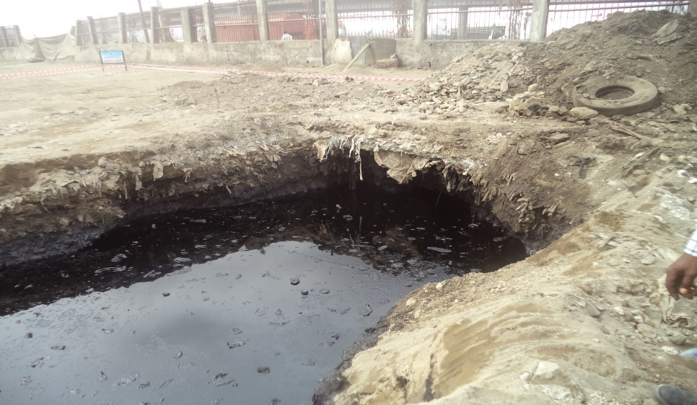
FIG 2: EXCAVATED PIT WITH A MIXTURE OF PRODUCT AND WATER (FEB. 2017)

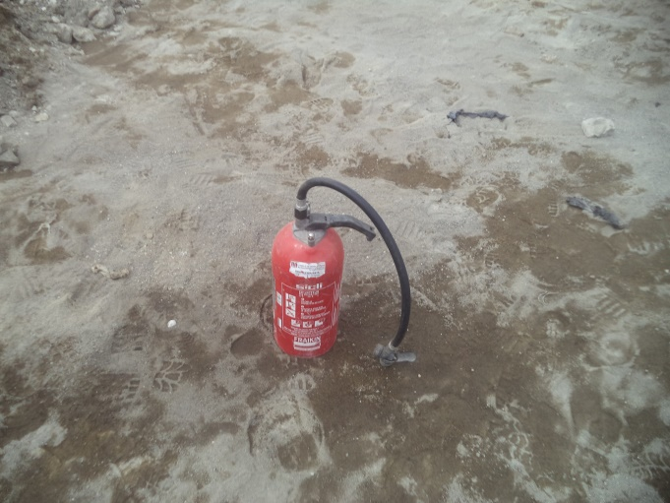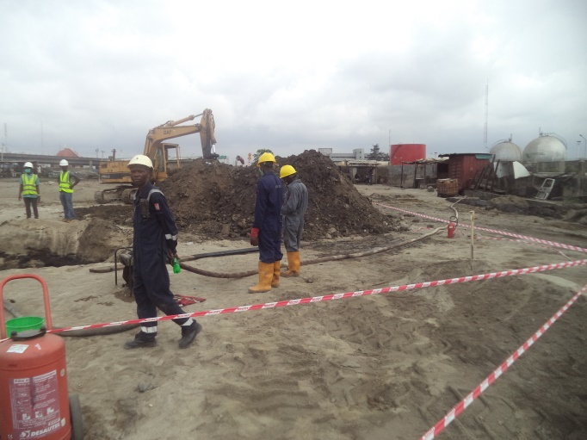
FIG 3: SAFETY EQUIPMENT AND PROPERLY KITTED WORKERS (FEB. 2017)

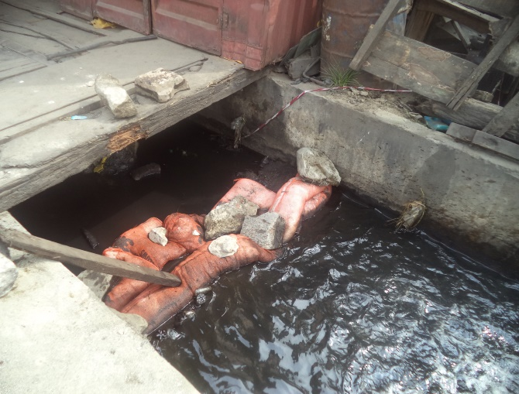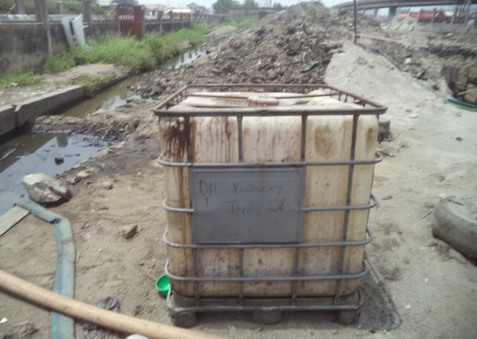
FIG 4: SOAKED ABSORBENT AT THE DRAINAGE AND RECOVERY TANK (FEB. – MARCH 2017)

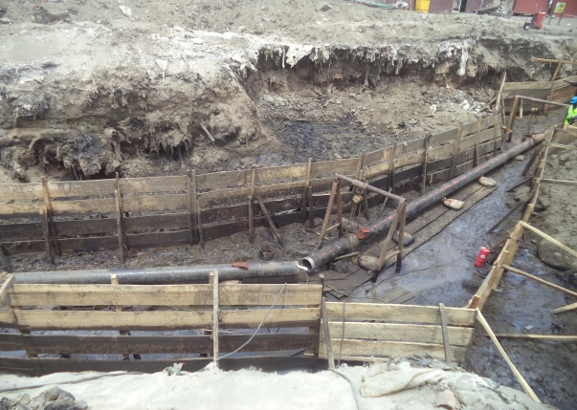
FIG 5: CROSS SECTION OF TACKED PIPE JOINTS (APRIL 2017)

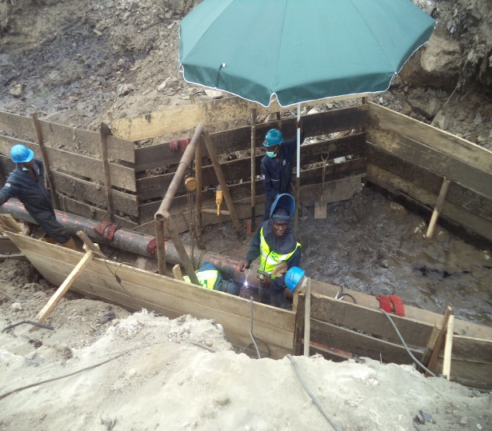
FIG 6: PREPARATION FOR WELDING OF PIPE (APRIL 2017)

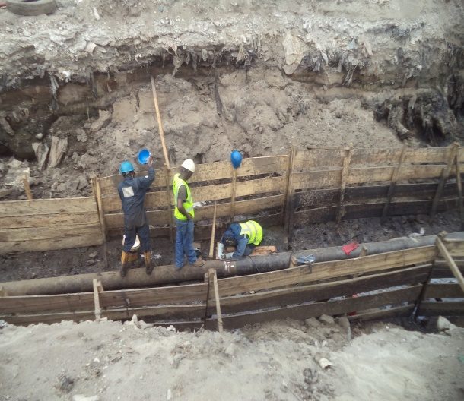
FIG 7: WELDING IN PROGRESS (APRIL 2017)

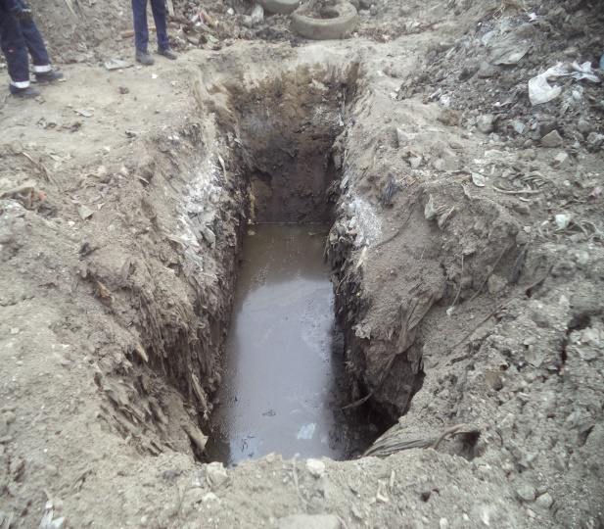
FIG 8: EXPOSED SECTION FOR INTEGRITY TEST (APRIL 2017)

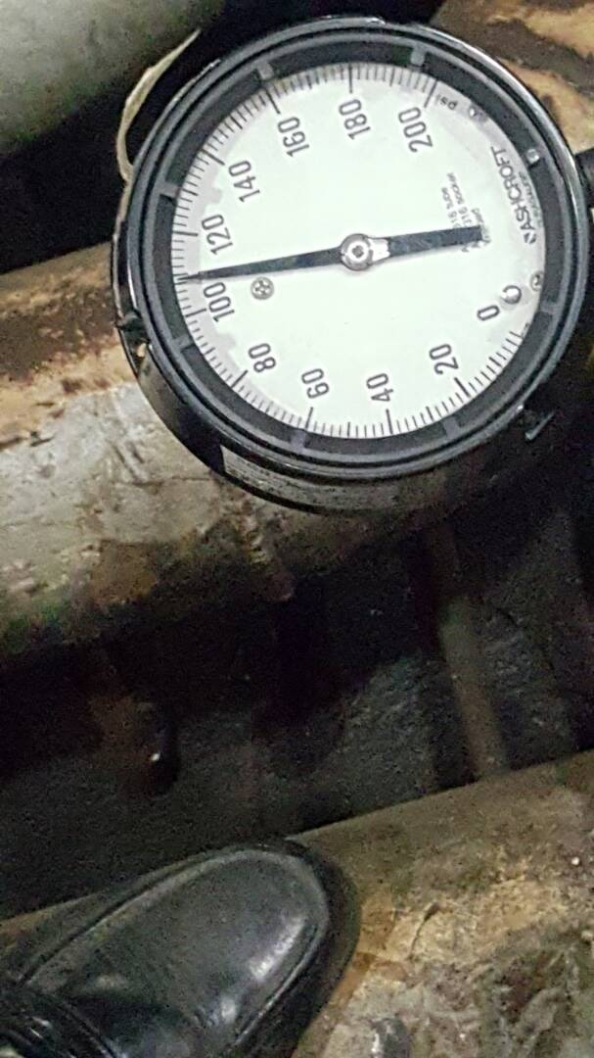
FIG 9: PRESSURE TESTING GAUGE FOR THE REPAIRED PIPE (MAY 2017)

